Electronic Recording System (Heart)

Submitted in partial fulfillment of the requirements

of the degree of

Bachelor of Engineering

by

Shreerang C Paradkar, Kedar N Patil, Amit D Sawant

Roll No. : 42, 44, 57

Supervisor (s):
Mrs. Sana Shaikh
Name of Supervisors

Department of Computer Engineering

Don Bosco Institute of Technology, Mumbai
(2014-15)
CERTIFICATE

This is to certify that the project entitled “Electronic Recording System (Heart Disease Prediction System)” is a bonafide work of Shreerang C Paradkar (42), Kedar N Patil (44), Amit D Sawant (57) submitted to the University of Mumbai in partial fulfillment of the requirement for the award of the degree of “B.E.” in “Computer Engineering”.

(Name and sign) (Name and sign)
Supervisor/Guide Co-Supervisor/Guide

(Name and sign) (Name and sign)
Head of Department Principal

Project Report Approval for B.E

This project report entitled Electronic Recording System (Heart) by Shreerang C Paradkar (42), Kedar N Patil (44), Amit D Sawant (57) is approved for the degree of B.E. Computer Engineering.

Examiners 1.---------------------------------------------

Examiners 2.---------------------------------------------

Date:
Place:

ABSTRACT

In medical field there is a growing need for development of software to be used for practical applications rather than only in research field. It is necessary to have a proper health care management system which should be 100% accurate but also should be portable so that every person carry with it as personalized health care system. Doctors need not only to know the main symptoms in a patient but also the other factors in life and surrounding that lead to disease in the patient. For collecting all the necessary information about the patient the doctors needs to spend a lot of time with the patient asking necessary questions to get the important details. The doctor needs to document all the data for further use and needs to keep track of all the patient details and remedies. The proposed system is intended to develop an Intelligent System using data mining modeling technique, namely, Naive Bayes. It is implemented as Java application in which user answers the predefined questions. It retrieves hidden data from stored database and compares the user values with trained data set. It can answer complex queries for diagnosing heart disease and thus assist healthcare practitioners to make intelligent clinical decisions which traditional decision support systems cannot.

CONTENTS
Serial No. | Contents | Page No.
CHAPTER 1 | INTRODUCTION  1.1 INTRODUCTION  1.2 AIMS AND OBJECTIVES  1.3 PROBLEM STATEMENT  1.4 SCOPE | 8  9  9  10
CHAPTER 2 | REVIEW OF LITERATURE  2.1 REVIEW OF LITERATURE  2.2 EXISTING SYSTEM | 11  11
CHAPTER 3 | ANALYSIS AND DESIGN  3.1 PROPOSED SYSTEM  3.2 METHODOLOGY  3.3 ANALYSIS  3.4 DETAILS OF HARDWARE AND SOFTWARE  3.5 DESIGN DETAILS | 12  12  17  18  19
CHAPTER 4 | IMPLEMENTATION  4.1 PLAN FOR NEXT SEMESTER | 22
CHAPTER 5 | CONCLUSION | 23
APPENDIX |  | 24
LITERATURE CITED |  | 25
ACKNOWLEDGEMENT |  | 26
LIST OF FIGURES
FIGURE NO. | FIGURE CAPTIONS | PAGE NO.
3.1 | The good-suffix shift, u re-occurs | 20
3.2 | The good-suffix shift, only a suffix of u re-occurs in x. | 20
3.3 | The bad-character shift, a occurs in x | 21
3.4 | The bad-character shift, b does not occur in x | 21
3.5 | Analysis of algorithm | 22
3.6 | Architecture of the proposed System | 23
3.7 | Remedy Generation | 24
3.8 | Data Collection | 24
3.9 | Segregation of symptoms | 25

LIST OF TABLES
TABLE NO. | TABLE TITLE | PAGE NO.
3.1 | Attributes of the proposed System | 14
4.1 | Implementation Plan | 22

ABBREVIATIONS
HDPS | Heart Disease Prediction System
IOS | iPhone Operating System
JDK | Java Development Kit

Declaration

I declare that this written submission represents my ideas in my own words and where others ideas or words have been included. I have adequately cited and referenced the original sources. I also declare that I have adhered to all principles of academic honesty and integrity and have not misrepresented or fabricated or falsified any idea/data/fact/source in my submission. I understand that any violation of the above will be cause for disciplinary action by the Institute and can also evoke penal action from the sources which have thus not been properly cited or from whom proper permission has not been taken when needed.

--------------------------------------
(Signature)

----------------------------------------
(Name of Student and Roll No.)
Date:
CHAPTER 1: Introduction

1.1 Introduction
Nowadays to live luxurious life people work like machine in order to earn lot of money hence they forget to take care of their health. Because of this, there is change in the food which they consume, their lifestyle changes. They are more tensed and in very much pressure to earn money so this leads to blood pressure, diabetes and various other diseases at young age. All these reasons lead to negligence of their health which increases the chances of heart disease. Heart is the most essential organ of the human body and if it gets affected then it also affects the other major organs of the body. The aim of proposed system is to design an automated system which would manage complete clinical details, patient’s history and their appointment details in a single database. Doctors will use this proposed system to keep track of the patient consulting to them. The intentions of the proposed system are to reduce over-time pay and increase the number of patients that can be treated accurately.
Many hospital information systems are designed to support patient billing, inventory management and generation of simple statistics. Some hospitals use decision support systems, but are largely limited. They can answer simple queries like “What is the average age of patients who have heart disease? ”, “How many surgeries had resulted in hospital stays longer than 10 days?”, “Identify the female patients who are single, above 30 years old, and who have been treated for cancer.” However they cannot answer complex queries like “Given patient records, predict the probability of patients getting a heart disease.” Clinical decisions are often made based on doctors’ intuition and experience rather than on the knowledge rich data hidden in the database. This practice leads to unwanted biases, errors and excessive medical costs which affects the quality of service provided to patients. The proposed system is that integration of clinical decision support with computer-based patient records could reduce medical errors, enhance patient safety, decrease unwanted practice variation, and improve patient outcome. This suggestion is promising as data modeling and analysis tools, e.g., data mining, have the potential to generate a knowledge rich environment which can help to significantly improve the quality of clinical decisions.
Quality service implies diagnosing patients correctly and administering treatments that are effective. Poor clinical decisions can lead to disastrous consequences which are therefore unacceptable. Hospitals must also minimize the cost of clinical tests. They can achieve these results by employing appropriate computer-based information and/or decision support systems. The healthcare industry collects huge amounts of healthcare data which, unfortunately, are not “mined” to discover hidden information for effective decision making. Discovery of hidden patterns and relationships often goes unexploited. Advanced data mining techniques can help remedy this situation. It is a prototype Heart Disease Prediction System (HDPS) using data mining techniques, namely, Decision Trees, Naïve Bayes. After successfully predicting whether the patient is prone to heart disease or not, the proposed system will provide with the set of questions which the patient will have to answer. Depending upon the answers given by the patient the pattern matching algorithm will generate the corresponding remedy.

1.2 Aims and objectives
The main objectives of the proposed System are
- The main aim of the proposed System is to reduce the paper work and to avoid missing of data
- To design a Heart Disease Prediction System which will provide automated medical diagnosis of the patient
- Storage of patient’s medical history into Database
- Generating different Diagnosis using Data Mining technique
- To calculate probabilities for a patient about the chances of Heart Disease
- To provide remedies depending upon the symptoms specified by the patient

1.3 Problem statement
- Development of software to be used for practical applications rather than only in research field.
- Doctors need not only to know the main symptoms in a patient but also the other factors in life and surrounding that lead to disease in the patient.
- The proposed system is intended to develop an Intelligent System using data mining modeling technique, namely, Naive Bayes. It retrieves hidden data from stored database and compares the user values with trained data set.
- It can answer complex queries for diagnosing heart disease and thus assist healthcare practitioners to make intelligent clinical decisions which traditional decision support systems cannot.
- The goal is to develop an automated system, which will facilitate the doctor to have health records of patients and generate e-prescriptions using data mining techniques.
- Once the data is extracted, cleaned and stored in the database, pattern matching is done with the medicine database to analyze the symptoms and provide a list of probable remedies. This will help the doctor to treat the patients.
- The doctor can enter his observations into the database using a desktop application. This will make it easier for him to keep track of all his patients’ recovery processes

1.4 Scope
- Mobile Application
- We can develop mobile application on Android and IOS platforms for making the system easily available.
- We can provide a SMS facility that will send a message to the patient regarding his heart condition and how to take effective measures to reduce the danger.

    - Pacemaker
- We can integrate the system with pacemaker. A pacemaker is a small device that's placed in the chest or abdomen to help control abnormal heart rhythms.
- This device uses electrical pulses to prompt the heart to beat at a normal rate.

CHAPTER 2: REVIEW OF LITERATURE

2.1 Literature survey
According to literature - 3, An Intelligent Heart Disease Prediction System (IHDPS) is developed by using data mining techniques Naive Bayes, Neural Network, and Decision Trees was proposed by Sellappan Palaniappan [3]. Each method has its own strength to get appropriate results. To build this system hidden patterns and relationship between them is used. It is web-based, user friendly & expandable.
According to literature - 1, The System can discover and extract hidden knowledge associated with diseases (heart attack, cancer and diabetes) from a historical heart disease database. It can answer complex queries for diagnosing disease and thus assist healthcare practitioners to make intelligent clinical decisions which traditional decision support systems cannot. By providing effective treatments, it also helps to reduce treatment costs. To enhance visualization and ease of interpretation, it displays the results in tabular and PDF forms.
According to literature - 4, This System helps us to understand data extraction using lookup tables by different techniques. Various Notations are used to denote different combinations. Data extraction can be done by performing logical operations on one or more variables in the records, or by comparing variables to values contained in a lookup table. This study focuses on using a lookup table to extract records.

2.2 Existing system
abc Homeopathy (abchomeopathy.com) [5]
abc Homeopathy is a free online homeopathic tool suggests homeopathic remedies based on the symptoms you enter. Homeopathy relies on gathering a detailed picture of your complaint before Homeopathic Remedies can be correctly prescribed. Therefore, for this homeopathic remedy finder software to work properly, you should enter all your symptoms, using the search or the tick categories, or both. You can add symptoms at any stage; you do not have to add them all at the beginning. [5]

Working of abc Homeopathy:
Enter your symptoms
The home page of the homeopathic remedy finder offers you a choice of Searching or Browsing to find your symptoms. If you choose to search, bear in mind that you are searching for symptoms, not a condition. (Search for headache, sore throat, exhaustion, sneezing, coughing and running nose rather than flu). It also allows users to group a symptom set by the name of a condition, but be aware that these conditions will not be exhaustive lists of possible symptoms. Although these are quicker and more convenient to use, you should supplement them with other symptoms specific to your case. The more symptoms you include, the more accurate the final result will be
Refine your symptoms
In most cases, the results of searching or ticking boxes produce more options such as exactly where, when and how symptoms occur. Depending on the precision of your search, you may also be presented with more options after that, as sub options from what you have already ticked. Homeopathy requires exact definitions of your symptoms to be useful. Therefore, there will be a maximum of 5 screens of tick-boxes to refine your symptoms. You can choose to ignore them, and just press next at any time to see the best remedy matches up to that point; you can of course then use the back button on your browser to resume ticking. If none apply, just press next.
Select a remedy
The aim is to find the one remedy which best matches all your symptoms. When there are no more questions to be asked, you will be presented with a screen showing details of the best remedy for your complaint. Usually the remedy will not be appropriate for all the symptoms you enter, and often there are other equally likely remedies. To differentiate between the most likely remedies, you can also see the remedy grid, with the symptoms down the left and the remedies across the top, by pressing the next button again. They are arranged with the best match on the left, and then less likely remedies to the right. A maximum of 12 remedies are shown at any time. With the remedy grid, you can easily compare remedies, and even rearrange the grid, prioritizing any symptom and discarding others.

CHAPTER 3: analysis and design

3.1 Proposed system
The Proposed system consists of the following modules:
3.1.1 Registration and Data Collection
- The patient needs to have his/her account. For that the patient needs to enter his personal details and create an account.
- After registration the patient will be provided with a unique username.
- The patient will have to fill the forms containing questionnaires. After the completion of forms, the proposed system database will be updated with the patient records.
- The doctor can also view the patient’s health records.

3.1.2 Finding the Probability
- After the collection of the data entered by the patient, the proposed system will generate the probability whether the patient is in risk of a heart disease or not.

3.1.3 Generating the Remedy
- Depending upon the probability of the heart disease of the patient, the further questions will appear.
- The symptoms will be entered by the patients and depending upon the probability and the symptoms, the remedy will be generated and will be displayed.

3.2 Methodology
The Heart Disease Prediction System (HDPS) is done using Naïve Bayes Data mining technique [1].
Record set with medical attributes was obtained from the Cleveland Heart Disease database. With the help of the dataset, the patterns significant to the heart attack prediction are extracted.
Questionnaires are also sharply limited by the fact that respondents must be able to read the questions and respond to them. Here our questionnaire is based on the attribute given in the data set, so the questionnaire contains

The records are split equally into two datasets:
- Training dataset.
- Testing dataset.

The attribute “Diagnosis” is identified as the predictable attribute with value “1” for patients with heart disease and value “0” for patients with no heart disease. “PatientId” is used as the key; the rest are input attributes. It is assumed that problems such as missing data, inconsistent data, and duplicate data have all been resolved.

Predictable attribute
- Diagnosis (value 0: <50% diameter narrowing (no heart disease); value 1: >50% diameter narrowing (has heart disease))

Key attribute
- PatientId – Patient’s identification number.

Table 3.1 Attributes of the proposed System
Serial No. | Attribute | Description
1 | Sex | value 1: Male  value 0: Female
2 | Chest Pain Type | value 1: typical type 1 angina  value 2: typical type angina  value 3: non angina pain  value 4: asymptomatic
3 | Fasting Blood Sugar | value 1: > 120 mg/dl  value 0:< 120 mg/dl
4 | RestECG | resting electrographic results  value 0 : normal  value 1 : 1 having ST-T wave abnormality  value 2 : showing probable/definite left ventricular hypertrophy
5 | Exang | exercise induced angina  value 1 : yes  value 0 : no
6 | Slope | the slope of the peak exercise ST segment  value 1: unsloping  value 2: flat  value 3: downsloping
7 | CA | number of major vessels colored by floursopy (value 0 – 3)
8 | Thal | value 3: normal  value 6: fixed defect  value 7: reversible defect
9 | Trest Blood Pressure | (mm Hg on admission to the hospital)
10 | Serum Cholesterol | (mg/dl)
11 | Thalach | maximum heart rate achieved
12 | Oldpeak | ST depression induced by exercise
13 | Age | In year
14 | Height | In cms
15 | Weight | In kgs

3.2.1 Bayes Rule
A conditional probability is the likelihood of some conclusion, C, given some evidence/observation, E, where a dependence relationship exists between C and E.
This probability is denoted as P(C |E) where
P(A | B) = P(B | A) P(A)
P (B)
Equation 3.1
For proposition A and evidence B
- P(A), the prior, is the initial degree of belief in A.
- P(A | B), the posterior, is the degree of belief having accounted for B.
- P(B | A) / P(B) represents the support B provides for A [1].

3.2.2 Boyer Moore
The algorithm scans the characters of the pattern from right to left beginning with the rightmost one [2].
In case of a mismatch (or a complete match of the whole pattern) it uses two pre-computed functions to shift the window to the right.

Assume that a mismatch occurs between the character x[i]=a of the pattern and the character y[i+j]=b of the text during an attempt at position j.
Then, x[i+1 .. m-1]=y[i+j+1 .. j+m-1]=u and x[i] y[i+j]. The good-suffix shift consists in aligning the segment y[i+j+1 .. j+m-1]=x[i+1 .. m-1] with its rightmost occurrence in x that is preceded by a character different from x[i] (Figure 3.1)
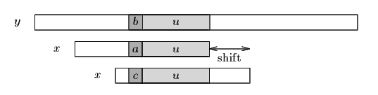
Figure 3.1 The good-suffix shift, u re-occurs

If there exists no such segment, the shift consists in aligning the longest suffix v of y[i+j+1 .. j+m-1] with a matching prefix of x in Figure 3.2.

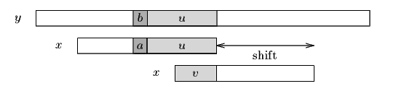
Figure 3.2 The good-suffix shift, only a suffix of u re-occurs in x.

The bad-character shift consists in aligning the text character y[i+j] with its rightmost occurrence in x[0 .. m-2] in Figure 3.3.

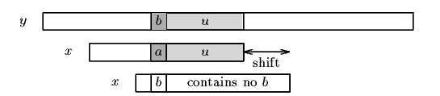
Figure 3.3 The bad-character shift, a occurs in x.

If y[i+j] does not occur in the pattern x, no occurrence of x in y can include y[i+j], and the left end of the window is aligned with the character immediately after y[i+j], namely y[i+j+1] in Figure 3.4.
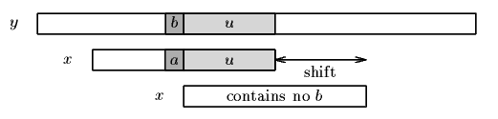
Figure 3.4 The bad-character shift, b does not occur in x.
Note that the bad-character shift can be negative, thus for shifting the window, the Boyer-Moore algorithm applies the maximum between the the good-suffix shift and bad-character shift.

3.3 Analysis
Analysis on classification algorithms
For classification module we require a efficient algorithm. From our analysis only Naive Bayes algorithm provides all the necessary accuracy.
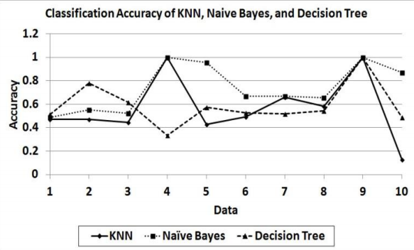
Figure 3.5 Analysis of algorithm
Although it is a simple method, Naïve Bayes can outperform more sophisticated classification methods. In this experiment, Naïve Bayes outperforms Decision Tree and k-Nearest Neighbor. The reason for Naïve Bayes’ good performance is not because there are no attribute dependences in the data. In fact its good performance is caused by the zero-one loss function used in the classification.
  - Details of hardware and software

3.4.1 Software Required
- XAMPP
- Eclipse
- JDK
- NetBeans
- MySQL

    - Hardware Required
- Server to connect to the database
- 2 GB Ram
- Pentium processo
  - Design Details
3.5.1 ARCHITECTURE OF THE PROPOSED SYSTEM
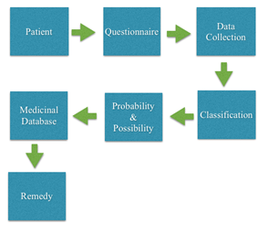
Figure 3.6 Architecture of the proposed System
The proposed system is done as Java Application. The patients need to answer various questions and the data is collected and then stored in the database. The data is classified (Figure - 3.6) based on the different possibilities. The patient can check whether he is prone to heart attack or not. The data entered by the patient is considered and the probability is generated whether the patient is in risk of getting the heart attack or not. Further questions are asked to the patient and depending upon the answers, remedy is generated. The medicine corresponding to a particular symptom is displayed. The doctors can view the patient details as well as the medicine database.

3.5.2 Remedy generation of proposed system
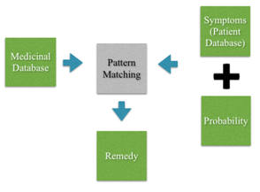
Figure 3.7 - Remedy generation
The symptoms are taken from the patient database and segregated into categories. These symptoms categories are matched with the symptom file created from the medicine database. After pattern matching the necessary remedies with their probability is displayed in Figure – 3.7.
The proposed system is divided into three parts
- Data collection
- Probability generation
- Generation of remedies

3.5.3 Data Collection
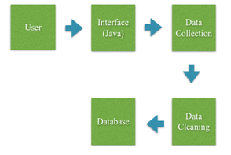
Figure 3.8 Data Collection
Data collection in Figure – 3.8 is meant to be used by the patients and the probability generation to be used by doctors or patients. In Data collection the main functionality of the system is carried out. The system would direct the patients to answer a few questions in order to get necessary diagnosis. The information collected from the patient includes personal details, associated complaints and reactions experienced. The symptom file is generated from the medicine database. The symptoms from the segregated sections are pattern matched with symptoms present in the symptom file. The matched symptoms are then used to generate remedies from the medicine database and the probability of the remedies. The symptoms are segregated depending upon the attributes in Figure – 3.9.
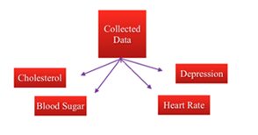
Figure 3.9 Segregation the symptoms

CHAPTER 4: implementation plan
Table 4.1 Implementation Plan
Sr.NO. | Month | Details of implementation
1 | January | Design of a entire GUI
 | January  January | Design and Development of Naïve Bayes Algorithm for Probability Generation  Design and Development of Pattern Matching Algorithm for Remedy Generation
2 | February | Implementation of Pattern Matching Algorithm
 | February | Integration of all Modules
 | February | Testing of all Modules

CHAPTER 5: CONCLUSION

Decision Support in Heart Disease Prediction System is a Java Application which is intended to be done using Data mining technique “Naive Bayesian Classification technique”. The system extracts hidden knowledge from the database. HDPS can be further enhanced and expanded. It can also incorporate other data mining techniques. Another area is to use Text Mining to mine the vast amount of unstructured data available in healthcare databases.

appendix
Appendix for Naïve Bayes Algorithm [1]
Required : Values of the attributes mentioned in the table 3.2
Algorithm :
Step 1: Calculate the mean and the variance of each attributes.
Step 2: P(A | B) = P(B | A) P(A)
P (B)
Where A and B are the different attributes.
Step 3: 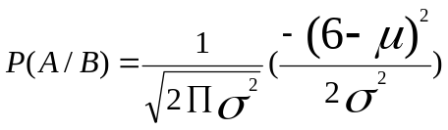
Where μ is the mean of that particular attribute and 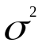 is the variance of that attribute

Appendix for Boyer Moore Algorithm [2]
- Cs(i, s): for each k such that i < k < m, s <= k or x[k-s]=x[k]
- Co(i, s): if s <i then x[i-s] != x[i]
Then, for 0 < i < m: bmGs[i+1]=min{s>0 : Cs(i, s) and Co(i, s) hold} and we define bmGs[0] as the length of the period of x.
The computation of the table bmGs use a table suff defined as follows: for 1 < i< m, suff[i]=max{k : x[i-k+1 .. i]=x[m-k .. m-1]}
The bad-character shift function is stored in a table bmBc of size 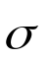

literature cited
- Shadab Adam Pattekari and Asma Parveen, “Prediction System for Heart using Naive Bayes” , International Journal of Advanced Computer and Mathematical Sciences ISSN 2230-9624. Vol 3, Issue 3, 2012, pp 290-294.
- ‘http://www-igm.univ-mlv.fr/~lecroq/string/node14.html’, Boyer Moore, accessed on 25th April,2014.
- SellappanPalaniappan, RafiahAwang, "Intelligent Heart Disease Prediction System Using Data Mining Techniques", IJCSNS International Journal of Computer Science and Network Security, Vol.8 No.8, August 2008.
- Anthony M. Dymond, “Data Extraction Methods in Medium and Large Databases”, Dymond and Associates, LLC, Concord, CA.
- “abchomeopathy.com” , accessed on 25th may,2014.

acknowledgement
We would like to thank our Internal Project Guide Mrs. Sana Shaikh, Research Head Mr. Ameya Kumar Tripathy ,Project Coordinator Mrs. Nilakshi Joshi, Head of Department Mr. Imran Mirza and External Project Guide Dr. Dilip Dixit for his continuous feedback and support that helped us throughout our Project.

-----------------------------------------
(Signature)

-----------------------------------------
(Name of student and Roll No.)

Date:
References
- Mrs. G. Subbalakshmi, “Decision Support in Heart Disease Prediction System using Naive Bayes”, Indian Journal of Computer Science and Engineering.
- Fayyad, U: “Data Mining and Knowledge Discovery in Databases: Implications for scientific databases”, Proc. of the 9th Int. Conf. on Scientific and Statistical Database Management, Olympia, Washington, USA, 2-11, 1997.
- Giudici,P.:“Applied Data Mining: Statistical Methods for Business and Industry”, New York: John Wiley, 2003.
- Han, J.,Kamber, M.: “Data Mining Concepts and Techniques”, Morgan Kaufmann Publishers, 2006.
- SellappanPalaniappan, RafiahAwang, "Intelligent Heart Disease Prediction System Using Data Mining Techniques", IJCSNS International Journal of Computer Science and Network Security, Vol.8 No.8, August 2008.
- Obenshain, M.K : “Application of Data Mining Techniques to Healthcare Data”, Infection Control and Hospital Epidemiology, 25(8), 690–695, 2004.
- Anthony M. Dymond, “Data Extraction Methods in Medium and Large Databases”, Dymond and Associates, LLC, Concord, CA.
- Raju Bhukya, DVLN Somayajulu, ”An Index based Forward Backward Multiple Pattern Matching Algorithm”, World Academy of Science, Engineering and Technology International Journal of Computer, Information, Systems and Control Engineering Vol:4 No:6, 2010.
- “APRIORI algorithm based medical data mining for frequent disease identification”, Gitanjali J, C.Ranichandra, M. Pounambal, IPASJ International Journal of Information Technology (IIJIT).
- Wu, R., Peters, W., Morgan, M.W.: “The Next Generation Clinical Decision Support: Linking Evidence to Best Practice”, Journal Healthcare Information Management. 16(4), 50-55, 2002.
- ‘http://www-igm.univ-mlv.fr/~lecroq/string/node14.html’, Boyer Moore, accessed on 25th April,2014.
- “Prediction System for Heart using Naive Bayes”, Shadab Adam Pattekari and Asma Parveen, International Journal of Advanced Computer and Mathematical Sciences ISSN 2230-9624. Vol 3, Issue 3, 2012, pp 290-294.

- “abchomeopathy.com” , accessed on 25th May,2014.

